

**Day 1: Arrival in Srinagar**

Welcome to Srinagar the city of Lakes you will met over representative and get transferred to Hotel and then local sight seen of Srinagar visiting Nishat, Shalimar Chesham shahi overnight stay in hotel in Srinagar.

###### Day 2: Drive from Srinagar- Sonamarg – Srinagar (100 km / 3 Hours)

After all the exciting experiences and astounding views in Srinagar, you will be driven to Sonamarg today. The drive will begin after your breakfast in the hotel and will take around 3 hours to complete. Fondly called the ‘Meadow of Gold’, Sonamarg is perched at a height of 9,000 ft. above the sea level and lies in the scenic Sindh Valley. Nestled amidst colourful and flowery meadows, your arrival in the hill station will be greeted by an exciting pony ride to the Thajiwas Glacier, which serves as one of the best Sonamarg attractions. Returning from the glacier, you will be driven back to Srinagar, where you can relish the day with a scrumptious dinner and overnight stay in the hotel

###### Day 3: Drive from Srinagar to Gulmarg (60 km / 2-3 Hours)

Today’s breakfast will bring an end to your Srinagar stay, and will take you to Gulmarg! Post breakfast in the hotel/houseboat, take an enthralling drive through the scenic trails of Srinagar and its hilly terrains to reach Gulmarg within 2-3 hours. Located at an altitude of 2,730m, Gulmarg or the ‘Meadow of Gold’ is one of the most popular and highest visited skiing destinations in the entire country. It is also in this hill station, you can visit the highest golf course in the world! During your drive, the panoramic views of the Nanga Parbat and Tangmarg will behold all your attentions for sure! Arriving in Gulmarg, join a 3-4 hours trek to Khilangmarg and witness the magical beauty of the hill station. Completing this trek, check-in into a hotel and enjoy your dinner with an overnight stay.

###### Day 4: Srinagar Departure

On the last day of your houseboat tour in Kashmir; after breakfast in the hotel, you will be driven back to Srinagar. Arriving in the capital city, the tour will come to an end with your drop either at the airport

### VAISHNO DEVI & SHIV KHORI TOUR PACKAGE

KATRA 03 N

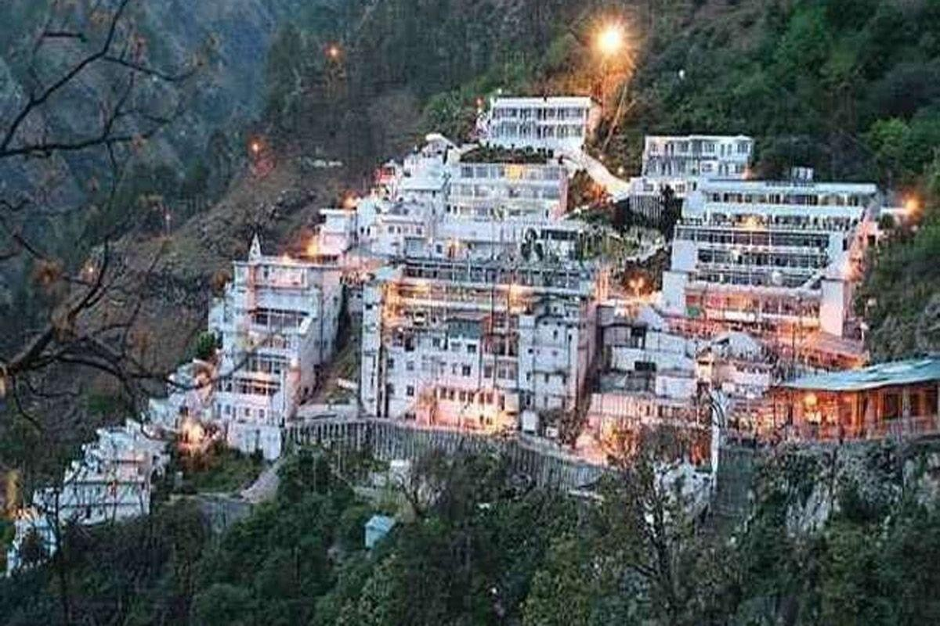

###### Day 1: Arrival - Jammu – Katra

Pick up from Jammu Airport/Railway Station and transfer to Katra (50 Kms/1.5 Hours). Spend rest of the day at leisure. Overnight stay at Katra.

###### Day 2 Katra - Vaishno Devi Darshans

Early morning after breakfast, proceed for Mata Vaishno Devi Bhawan- one of the most popular pilgrimages of India situated in the lap of Trikuta mountains across Katra town at an altitude of around 5200 feet. Yatra involves a trek of nearly 12 Kms from base camp at Katra known as Ban Ganga. Alternate way to perform darshans is by Ponies/Palkis/ Helicopter. If time permits, visit Bhairo Temple & return back to Katra in the evening. Overnight stay at Katra

###### Day 3: Katra - Shiv Khori – Katra

Early morning after breakfast, proceed for Shiv Khori - the Holy Cave abode of Lord Shiva situated at a distance of 70 Kms from Katra. The cave is a real wonder to be seen and measures nearly half a kilometer in length with a 4 feet high naturally formed Shiv-lingam at the heart of the Sanctum Sanctorum. Have darshans of Lord Shiva and back to Katra in the evening. If time permits, en route, visit Siar Baba waterfalls, Baba Dhansal & Nau Devis. Overnight stay at Katra

###### Day 4: Katra - Jammu – Departure

After breakfast, check out from the hotel & proceed for Jammu to drop at Airport/Railway Station for your onward journey with sweet memories of the tour.